
Matthew Glanfield presents…
BBO Infinite Profits Part 2
The Road to Residual Profits
A beginner’s fast-track to the infinite profits of the web…


All material contained in this e-book is Copyright © 2008 Glanfield Marketing Solutions Inc. and may not be reproduced, redistributed, or resold without prior written consent from this company.

Legal Disclaimer: While all efforts to provide correct information have been made, we cannot guarantee any success or any sort of income from reading this e-book. We do have confidence that if you read and study this e-book, and APPLY what is taught, that you can see great wealth through your own Internet business. However, we cannot legally guarantee anything. We are not responsible for the loss of income, time, or any damages that applying what is taught in this e-book may cause (although we don’t think that any of that will happen!).
Preface – A Brief Recap…

Before reading this e-book you should already have read BBO Infinite Profits - In The Beginning, which is basically Part 1 in the BBO Infinite Profits series.

Without the context of Part 1 most of what is here won’t make sense and won’t work.

Also, I strongly suggest that you apply what you have learned in Part 1 before attempting to apply what you are about to learn here. There is nothing wrong with “reading ahead” before you are ready to take action, but please understand that Part 1 is an essential foundation for the BBO Infinite Profits system.

The only exception to this rule would be if you have a few thousand dollars you are willing to invest in creating your continuity product (this will be explained in this e-book) before you make any money.

Having said that, let’s jump right into what I consider to be the exciting part of the BBO Infinite Profits system – Your Road to Residual Profits.

Best of luck,


Matthew Glanfield
Chapter 1 – The Back-End Continuity Model

Hopefully by this point you understand that the purpose of the BBO Infinite Profits business model is to create sustainable, steady, reliable income that you can profit from month after month.

The basic idea of a continuity product can be summed up into three words:

Monthly Recurring Fees

Let me ask you this – which of the following do you pay for:

- Phone?
- Cell Phone?
- Internet?
- Web hosting?
- Cable or Satellite TV?
- Mortgage?
- Property Taxes?
- Credit Card Payments?

Now, what do most of these have in common? They all charge you monthly fees!

Some of them may charge you every quarter (such as land taxes) or even every year (such as web hosting), but even those could be broken down into a monthly fee.

(We’ll talk more about pricing structures and monthly vs. quarterly vs. yearly vs. lifetime payments in a later chapter.)

Here is the interesting thing:

Most of your expenses are monthly recurring fees!

Now, we’ve already discussed the advantage of residual income and continuity products, but I wanted to emphasize even more how much this can help to stabilize your income.

Because once you realize that your income does not equal your sales, you will see the importance of having a continuity product.

Remember, no matter how little or how much you make this month, your expenses will be roughly the same. And as your business grows, so will your monthly expenses, so you may as well have your residual monthly income increase as well!

I received a question about this recently from somebody interested in this system.

They asked:

“What if the market I am in wouldn’t support a monthly recurring payment?”

In other words, what if the people in the market that you are in wouldn’t like the idea of paying a monthly fee (i.e. markets that have such low profit margins and such low prices that it would be hard to convince anybody to pay monthly).

My answer is simply:

Get out of that market!

In BBO Infinite Profits Part 1 we discussed choosing a profitable market. If you followed the guidelines there then you shouldn’t run into this problem.

Remember, we are going where the traffic and money is, not just trying to make it come to us in our corner.

There are two main models of continuity products that I want to go over. You are going to have to choose one of these models for your first continuity product, so I want to make sure you are well educated as to the advantages and disadvantages of both.

Here they are:

Continuity Model #1 – Membership Sites
Example: www.bbotrafficclub.com
Membership sites are sites where members pay monthly to access themed information (i.e. information around a given topic) as well as to be part of a community.
In other words, they will expect to see regularly updated content in order to continue paying on a monthly basis.

Continuity Model #2 – Software Sites
Example: www.yoursqueezepage.com
A software site is a site where people pay monthly to access some software tool that helps them in their day-to-day (or week-to-week or month-to-month) habits.

In both cases you need to make sure that the members of the continuity site will continue to need your services on a long term basis.

Examples of Membership Sites:
- New exercises to lose weight
- Stock graphics for web designers
- Video marketing done right
- Profiting from eBay
- Tips for increasing sales at your restaurant (real example)

Examples of Software Sites:
- Weight loss tracker
- Search engine rank tracker
- Audio / Video hosting
- Website creation software
- Traffic generating software

These are just a few examples of the myriads of ideas that you could come up with in your own market.

Just think about what your customers need on a regularly basis, and usually you can come up with some sort of continuity site from it!

Which model should you choose?

There are definitely advantages and disadvantages to each of these models, and I want to go over both.

But before I go further, understand that I am not going to sway you to one side or the other – you need to choose based on your resources and your knowledge so that you can make as much money as possible.

I actually use a mix of the two types. My one site, www.bbotrafficclub.com, is actually a membership site combined with some software.

My other sites, www.yoursqueezepage.com and www.theadninja.com (amongst many others to come), are both software sites.

Membership Sites
Advantages:

- easy to create
- lots of resources to find content from
- easier to create community atmosphere

Disadvantages:

- higher maintenance
- harder to lower attrition
- harder to keep interest

Software Sites
Advantages:

- can be easier to maintain
- easier to lower attrition
- easier to keep interest
- less time required to maintain

Disadvantages:

- harder to create
- requires larger investment of time and money
- harder to create community atmosphere

Think of it this way – the two main things that you need to worry about when it comes to continuity products are:

Customer Acquisition and Customer Retention

Getting customers is not as hard as you think; it is keeping customers that can be harder.

In short, a membership site will be much less time and money intensive to create, but will require more maintenance to ensure that your retention rate (i.e. how many people stay instead of cancel) stays high. A software site is much harder to create, but will require less maintenance to keep customers around.

A prime example of this is with YourSqueezePage.com. Initially I put in thousands of dollars to create this software, but afterwards had to do very little to maintain it. And because of the nature of the software, it is easier to keep customers without updating it very often.

If this isn’t enough to help you choose, allow me to break it down into a simpler way of looking at it.

Answer this question:

Do I have the resources (i.e. time, money, and knowledge) to find and manage programmers to create and maintain software?

If the answer is no, then do a membership site at first.

This doesn’t mean you couldn’t do a software site, it just means that you will most likely have more success with a membership site.
Chapter 2 – Designing Your Continuity Product

Once you have chosen the type of continuity product that you are going to create (i.e. software or membership site) you will need to design the product before you can create it.

There are major differences between the design of a membership site and of a software site. However, I am going to focus more on how to create a membership site, mainly because if you decide to do software that would mean that you have some resources to help you with that process.

A lot of the principles that go along with membership sites also go with software sites, so it would still be useful to read the following chapters before proceeding with your project.

Also, in this chapter I will not be going over things like software to use for your membership site or estimated costs. That will all be covered in Chapter 3.

The Two Most Important Factors in a Continuity Product

Whenever you are designing a continuity product you have to keep two important factors in mind. They are:

- Customer acquisition (i.e. getting customers).
- Customer retention (i.e. keeping customers).
Your job is to design a product that will almost take care of these two factors by itself (obviously you will have to do some work getting traffic to get new customers, and your customer support will have to do a good job of keeping customers as well).

So how do you design your product with these two factors in mind? Let’s go over each one.

1. Designing Your Product to Facilitate Customer Acquisition

From my experience it is not easy to sell a continuity product. I remember being an affiliate for two launches of a product by a well-known marketer. In the first launch he sold the product for a one-time fee of $197.

In the second launch he sold the product along with a continuity membership to get updates for $97 per month.

In the first launch I made over $16,000 in sales. In the second launch (which I emailed just as much for) I made about $500 in sales.

There are obviously other factors involved as well, but in my opinion one of the main reasons that it didn’t do as well was because most people don’t want to get roped into a long-term monthly recurring payment system.

So how do you overcome that? Somehow, you need a hook that gets people in, and then you can of course focus on retention (which is easier than acquisition by the way).

Here is how I like to overcome the acquisition difficulty when designing my product:

a. Choose a theme that your customers REALLY want.

The first step is to choose a theme that your customers really want. If you are in the Internet Marketing niche, it is simply not enough to have an “Internet Marketing Membership Site”, as this is too broad and does not really make people want to sign up.

Instead, you should choose something more “hot”, such as traffic generation or Web 2.0. By choosing a hot theme for your membership site you will make it more desirable for your customers.

b. Create a high-value “core-training” product.

This is the main “hook” that I was speaking of before. People are interested in getting a lot of information all at once, but not just in the form of a bunch of articles and videos.

This is why you should always create a “core-training” product to go along with your membership site.

For example, if you are going to sell a membership site in the fitness industry where you show new exercises and routines every month, you should also include you “3 DVD Set” of one of your best programs.

(Of course it doesn’t have to be a physical product; it can just be a downloadable product.)

And the great thing is, you already have this product! Just take your front-end product that you have been selling and use that as the core training.

This works great as it gives your prospects something to “buy” when they purchase their first month of your membership site. Instead of just purchasing access to your site, they are purchasing the core training, and then continuing to pay monthly for the other information you will be providing.

c. Give away free months to your customers.

The other way to overcome the acquisition end of the design of your membership site is not so much in its design, but in giving away one or two free months to people who buy your other products.

We will talk more about this in Chapter 4.
2. Designing Your Product to Facilitate Customer Retention

The other issue that you need to deal with is the fact that every one of your members is eventually going to cancel, no matter how great your site is.

Now, you can choose to not care about this and just deal with the normal dropout rate of around 2-3 months, or you can design your product to make it incredibly painful for your customers to cancel.

I have a friend who signed up for a membership site that cost him several hundreds of dollars per month. After the first few months he stopped using the site, but didn’t cancel for another few months afterwards because he was afraid to lose the bonuses that he received as part of the membership site.

In fact, it was painful for him to finally cancel the membership that he had.

That is exactly what you want your customers to feel when they start looking at their monthly expenses and see what they can cut out.

You want your membership site to rank alongside their phone bill and heating. It needs to be essential to your customers.

Ok, enough of beating the dead horse. I think you get the idea.

So how do you make your membership site essential to your customers? I’ll go over a few ways now.

a. Have a source of high quality content that you continually add.

The first thing would be to make sure that when you are designing your membership site that you have sources of information that you can continually add.

Here are a few sources:

- Yourself
- Industry Experts
- Article Directories
- News sites

This is not all inclusive, but gives you a great start. The best source of information is yourself and other experts, so make sure that you choose a theme that you will be able to create more content for.

If you are not an expert on the subject, then become one! Invest your time and money into a few high-end information products and learn the ins and outs of what it is you are trying to teach, and then turn around and teach those ideas in your own words.

Hosting regular interviews with industry experts not only provides you with more content but it also helps to form new JV relationships that you can work with to get more customers.

You can also use article directories to create new content for your membership site. However, only include high quality articles that will help your customers. If you give them junk, they will cancel.

News is great content. People are always afraid of not being “up to date.” One of the selling features of your membership site could be to keep them up to date with news from your particular industry.

By providing regularly updated news your membership site will become a resource that your customers will not want to give up on very easily.

b. Build a strong sense of community

A strong community will also keep your customers paying month after month. You can do this with a simple forum, although it will take some work to get going, especially when you only have a few members.

The best way to get a forum going is to be active on it yourself. Whenever people post, reply! If you do this for the first few months you will most likely find that you have a thriving forum that your customers will use to communicate with each other and with you.
c. Include bonuses that only work if they continue on a monthly basis

This is a little tougher, but if you use your imagination you should be able to come up with a couple of ideas.

For example, if you run a weight loss membership site, why not include a fitness tracker that allows them to track their weight loss and activity? If they cancel they lose the ability to continue tracking themselves.

Or, another easy bonus to add would be a monthly Q&A call where your customers can get on the phone with you for an hour or two and ask you whatever questions they like. This is a highly perceived bonus that I use with many of my products.

A note on software sites…

The advantage of running a software site is that most of these factors are built in, especially if your software will only work as long as they continue to pay.

That is why it is important to avoid “stand-alone” software (i.e. software that the customer can download and then continue using without needing your site). I highly prefer online software, such as what you see at www.yoursqueezepage.com, because once the customer starts using it, it is very hard to cancel.

I had an audio hosting membership with a company for several years even though I had switched over to a better company with better rates a long time ago. The reason I didn’t cancel was because I had their audio players on so many sites that it would take me hours of work to find them all and replace them.

Now, this leads to another important point with software sites – get your customers to USE your software.

The easiest way to do this is to have a follow-up sequence of emails in your auto-responder that trains the customer on how to use their new software. Include articles and videos to show them the basics and all the advantages of their new software.

Remember, for customer retention they need to use your software, otherwise it is just an unnecessary expense that they will eventually cancel.

What about Pricing?

Another part of designing your continuity product is determining the pricing of the monthly fee.

The easiest way to do this is to do a bit of competitive analysis. Take a look at what other sites are charging and what they are offering for that price, and then compare it to your own site.

There is no magic number to use. It all depends on the value of what you are offering, and how much your customers normally pay for that value.

What I like to do is check out the competition, find the industry standard for the pricing, and then go slightly below it to be competitive. I don’t like to largely undercut my competitors as that only leads to price wars and it cuts down on my profits greatly.

If you can’t find any obvious direct competition then you may have to look a little further for ideas.

For membership sites I generally like to charge at least $20 to $30 per month. Otherwise you need a ton of customers to generate any real profits.

Creating More Than One Membership Level

Something else that you can consider is creating multiple levels of membership, giving much more to the higher levels than the lower levels.

If you are going to do this then I have one suggestion – use 3 levels of membership.

This is a well-known marketing technique in the offline world. Here is how it works:

- Create 3 levels of membership.
- Price the first level at an “entry-level” fee (e.g. $19.95).
- Price the second level much higher than the first level, but add a lot of benefits to upgrading (e.g. $39.95).
- Price the third level a little higher than the second level, but add even more value (e.g. $49.95).

What this does is provides a low-level fee for those that don’t want to pay a lot, and for those that want to get more benefits they will usually take the top plan as it is only a little bit more than the second plan but has so much more!

Here is how it works in your prospect’s mind:

“Ok, $19.95 per month is worth it, but if I upgrade for only $20 more I can get A and B. Yeah, I’ll do that. Well, for only $10 more I can get C, D, and E.”

I have found that 50% of people who sign up for a membership end up taking the highest paying plan, 40% take the lowest plan, and only 10% take the middle plan, which shows that this works!

The only difficulty with having three plans is that it might be a little confusing to choose from, which would perhaps lose you some of your potential customers.
An alternative to this would be to have the entry level cost be what all customers take, and then up-sell them to the higher level memberships once they are on the inside. This is a tactic that I have recently taken with some of my sites, so I don’t have enough data at this point to be able to say if it is better or not.

In the end, price your program to be competitive but not so low that you don’t make any money.

Trial Memberships

There are differing opinions on offering trial memberships to your customers. Those who are against it don’t like the idea of getting freebie seekers and are afraid that members will come in, download everything, and then cancel.

Those who are for it (which includes myself) don’t really care about the few people who abuse it and love the fact that 10-20% conversion rates are easily achievable because of how easy it is to get somebody to start a free or $1 trial.

In other words, my strong advice to you would be to offer a trial membership.

How much and how long?

When I first created the Affiliate Marketing Formula (www.affiliatemarketingformula.com) I offered a payment plan for the $97 product that I was selling. People who didn’t want to spend $97 now could instead pay $1 for 30 days of access, and then pay two payments of $50.

This greatly increased my sales, but also increased complaints as 30 days later people wouldn’t remember that they were going to be charged.

My response was to lower the trial period from 30 days to 14 days. Not only did I still get the same sales conversion rate (i.e. I would get just as many sales as before), but there were FAR less cancellations and complaints!

That is why you will notice that most of my sites offer a $1 14-day trial membership, and that is what I suggest that you do as well.

Let’s review what you have learned in this chapter.

Designing Your Continuity Product
- Choose which type you want (software or membership).
- Choose a theme.
- Determine core training (use a product you already have).
- Determine sources of future content.
- Determine pricing and plan levels.

Pretty simple, isn’t it? The design phase really shouldn’t be too hard. The trick will be implementing it, which is exactly what we’ll cover in the next chapter.

Chapter 3 – Creating Your Continuity Product

Now for the fun stuff!

Actually, once again this is the part where a lot of people get hung up, not knowing exactly what to do.

What I am talking about is that four-letter word that we all hate to see:

The TECH Stuff…

Try as you may, it is hard to avoid.

However, just like what I taught you about creating the website to sell your first product, you can outsource most of what needs to be done in order to get your membership site created.

There are several ways that you can approach creating your membership site. Here are a few:

- Do it yourself from scratch (difficult, but cheap).
- Use software to do it yourself (somewhat difficult, inexpensive).
- Use hosted software to have it done for you (somewhat simple, not cheap).
- Have a custom solution created for you (very simple, expensive).

Now, unless you are a savvy programmer, stay away from #1. Also, if you are technologically challenged, then stay away from #2.

The “Technologically-Challenged” Quiz
How do you know if you are technologically challenged? Simple! Tell me how many of these terms you are familiar with and understand what they mean:
- HTML
- FTP
- PHP
- MySQL
- cPanel
- phpBB
If you only understand one or two (or less) of those terms, then you are probably technologically challenged.

If you know how to use FTP and MySQL databases, then #2 can work for you and save you some money, but may end up causing a lot of frustrations.

That leaves us with #3 and #4.

So, should you get a custom solution or use hosted software?

First off, let me explain what “hosted software” is. Hosted software is a solution whereby you pay a subscription fee to have your membership hosted.
This means you don’t have to install anything, modify anything, or worry about FTP, MySQL, or anything else like that.

Of course, you will still need to provide all the content and do all of that work (and get graphics designed as well), but it is WAY easier than using downloadable software that you have to upload, modify, install, and configure yourself.

Custom solutions will almost always be the most expensive, but they will allow the most flexibility when determining what it is that you are trying to achieve.

(You can find my recommendations for all of these options in the resource section here: http://www.bboinfiniteprofits.com/resources.php)

I am not going to go over specific software here in this e-book mainly because there are so many changes that happen quite rapidly in this market, so your best bet is to refer to the resources page at the link above.

However, what I do want to do here is explain the system that I use to create membership sites, just like I explained the system for creating your sales site. You should learn and understand this system so that you can communicate effectively with your web designers and programmers. Also, this will allow you to research tools effectively and see if they can really help you out.

And remember, the systems I use are always evolving according to testing, so be sure to test new things out for yourself to see how well they really work.
The Infinite Profits Continuity Product Website System
1. Home Page
(with free offer)
2. Benefits Page
(with video tour)
3. Register Page
(That’s a mouthful…)

4. Payment Processor

5. Members’ Area

Once again you should notice that this is not a complex system. I like to keep it simple.
You should also notice that while this is similar to how you sell an e-book or any other info-product, there are some significant differences as well for selling a membership site or software program.

To illustrate each step I am going to use an example from one of my sites, www.bbotrafficclub.com. Now, remember that I am always testing out new ideas, so the screenshots that you see here will probably not be the same as what you see on the site now.

However, the basic system should still be there, unless of course I discover something that works even better, in which case I would need to update this e-book.

So let’s go through each step now.
1. Home Page
(with free offer)

The home page has two purposes:

- Build your prospect list.
- Generate interest in your membership site, and prepare the prospect for the sale.

Here is a screenshot of the top of my home page on www.bbotrafficclub.com:
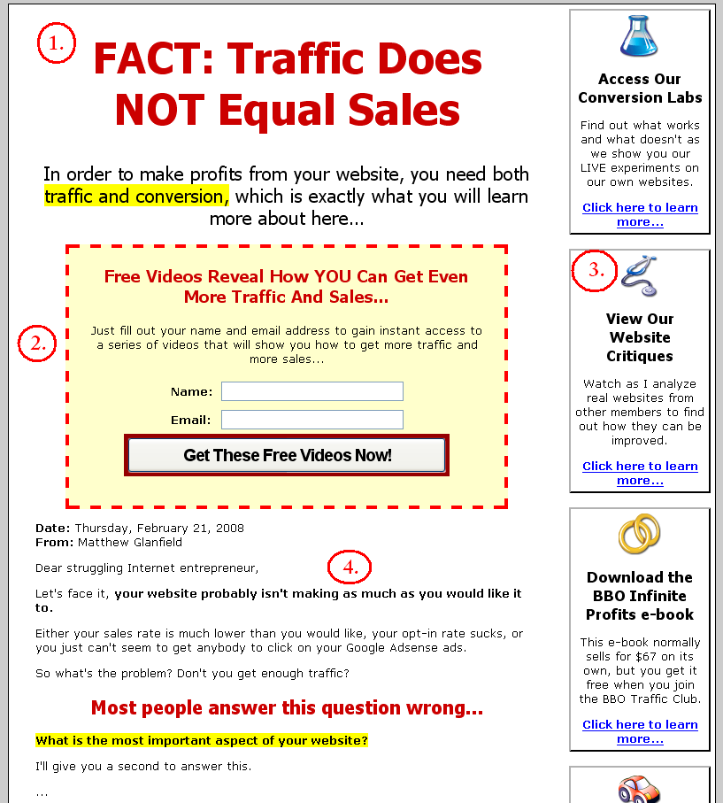

I have added the four numbers so that you can reference the various elements. I’ll go over this part first, and then show you the bottom half of the page.

1. The Headline.

Just like a squeeze page or a sales page, you should have a strong headline that will create curiosity and start the selling process.

I won’t go into great detail here about how to create a good headline as that is covered in the previous e-book.

Also, you should notice that there is no graphical header on this page. After extensive testing I have found that it is usually better to not have a header graphic included on the page.

2. The free offer.

In order to generate a prospect list that you can sell to (and sell affiliate products to later on) you need to offer something of value for free. This should be something that is related to what your membership site is all about.

I find that the easiest thing to offer is a set of videos that you create. You can even use videos from the inside of your membership site, removing the need to create anything new!

Make sure this offer isn’t simply for “more information” or to be added to your “newsletter.” Both of those are boring and will get very little response.

So why don’t we just make the home page a squeeze page?

As an avid preacher for the use of squeeze pages, I have found that it is better to use this format for a membership site.
I’m not 100% sure why this works better, but I have a strong feeling from the testing results that I have received that it is due to the mindset of the visitor who comes to the site.

Because a membership site is a harder sell it is necessary to allow the user to feel more in control with the whole signup process. By presenting them information in a variety of formats, along with offering them free information, the results will definitely increase.

HOWEVER, this doesn’t mean that you shouldn’t just plop a squeeze page on your home page and see what happens. Once you are ready, you should start testing different variations on this idea for yourself, and see if you can get even better results.

3. Initial Benefits.

On the right hand side I have placed some of the benefits of joining the membership site. There are two main reasons I do this:

- It forces me to determine what the real benefits to joining are.
- It allows different visitor types to find something that interests them.
Now, this might seem odd as usually in info-product sales processes we try to simplify the choices that a visitor has.

However, in reality this page remains very simple as there are really only two things that a visitor could do – sign up for the free offer or go to the Benefits Page. All of the links that you see in the screenshot go to the same place in the sales process, so really we are controlling the user experience quite strictly.

4. Initial Sales Letter.

On the home page I also like to include a “preparatory sales letter.” This isn’t a full sales letter, but more a “message from me” that starts the process of building trust.

I like to use this space to either tell a short interesting story, or to tell the visitor why they should even continue on to the next page.

The last thing that is on this page is shown on the screenshot below:

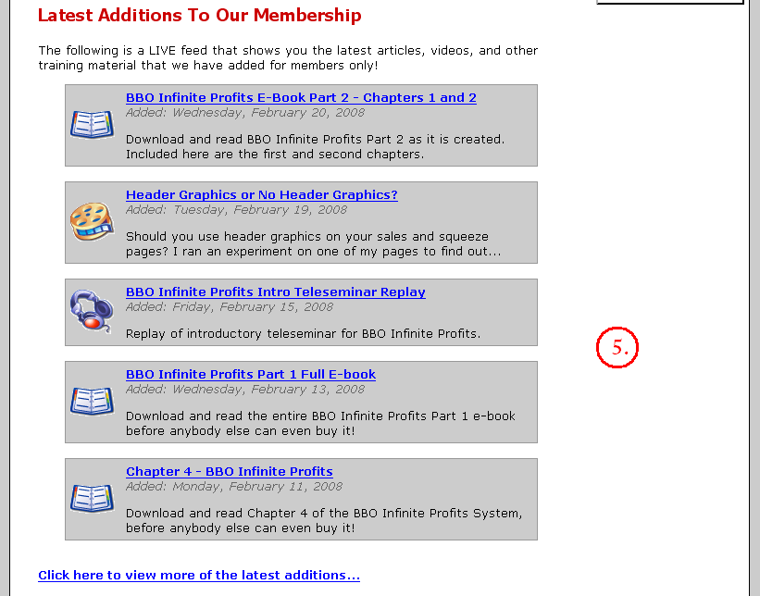

5. Preview of Content.

This is another sales tool that you use to generate interest in your membership site. I like to have a live feed on the home page displaying the five latest additions to the membership site, along with a link at the bottom of the page that allows the visitor to see even more.

All of the links on each of the items leads to the benefits page, but to the user they think that they can click on them to read the article, which preps them perfectly for the sales process that is to come.
2. Benefits Page
(with video tour)

The next step in the sales process is what I call the benefits page. It is much like the salesletters that we write for our info-products, and in fact can be just that.

However, I chose to do a slightly different format, focusing simply on the benefits of the membership and strongly emphasizing the $1 14-day trial that I am offering.

Remember, the goal here is to convince the visitor to sign up, so you need to focus on why they would want to sign up, not on how cool your membership site is.

This is best done with a benefits-oriented page and a high-quality video tour of the inner workings of your membership site.

Here is a screenshot of the top of my benefits page:

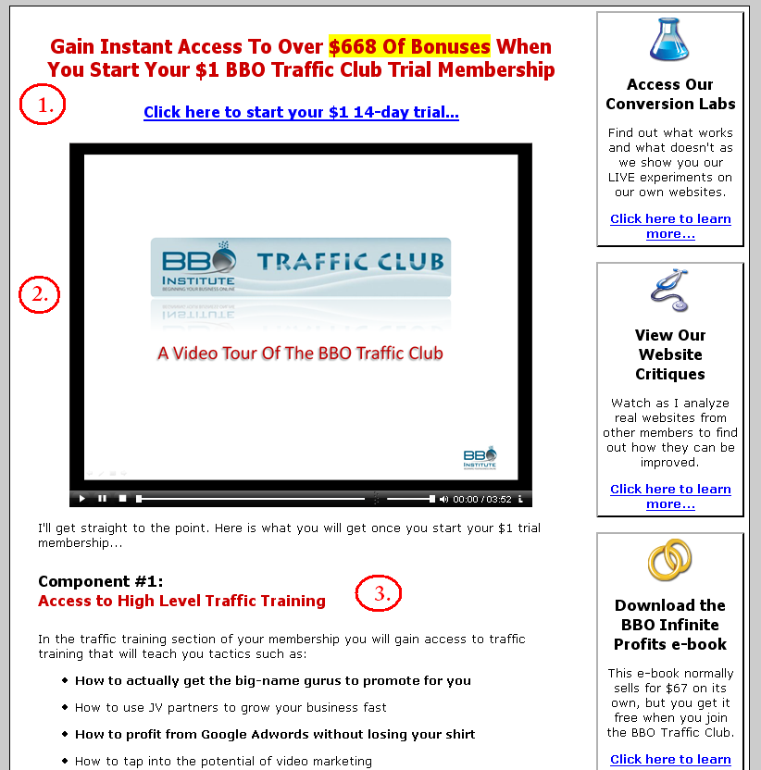

Let’s go through each component again.

1. Headline and link to start trial.

After researching many other membership sites I decided to try a headline that focused on all of the bonuses that the visitor would receive when they started their $1 trial.

In reality this is just a normal headline that you can use in exactly the same way that you would on a sales letter. In fact, if you go to my benefits page now you will probably see a new headline as I am constantly testing new ideas!

2. Video Tour.

This is powerful, and not as hard as you may think.

I spent four minutes recording myself talking while poking around my members’ area and turned it into a video tour!

I did this using software that could do screen-capturing (basically it records the screen and anything that you do on it along with your voice over the microphone).

You can refer to the resources page to find the software that I used: http://www.bboinfiniteprofits.com/resources.php

It is powerful because it gives visual learners a way to see for themselves what you have to offer, and it allows you to have a “non-sales environment” where you can sell your membership.
3. Benefit list (or sales letter).

Here is where I simply list off all of the components of the training, along with the bonuses that the customer will receive.

You can, of course, insert a full-blown sales letter that you spend a long time creating, and that will probably help increase your sales.

I’m lazy, so I didn’t. ;)

The truth is, I want this process to convert enough to be happy with, because I will be focusing mainly on getting customers through other means such as offering free months to customers of my other products and also to JV partners’ customers.

Let’s look at the bottom half of the page now:
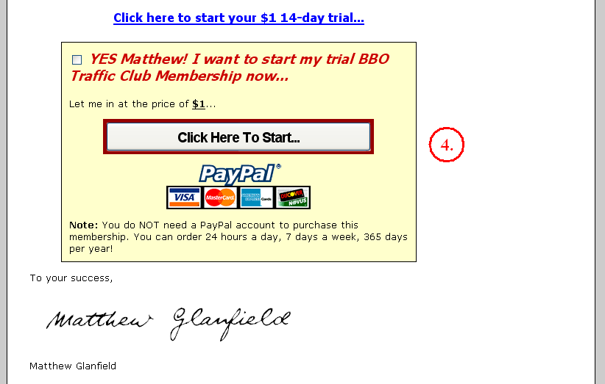

4. Sign up box.

The only thing really left is to ask for the sale! I focus heavily on the $1 trial at this point. In fact, I haven’t even told the visitor how much the monthly fee is, nor do I until they are ready to enter their credit card information!
3. Register Page

This is short and sweet. Here are the two screen shots of the two pages that my visitors go through to register. You could condense these into one step as there really isn’t that much information that you are asking for.
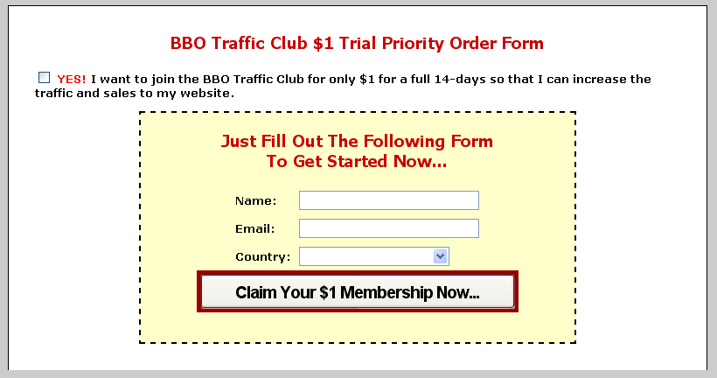

I am asking for the country as I have to charge sales tax to any Canadian residents. If you don’t have a reason to ask for the country, then leave it out. The less you ask for the better.

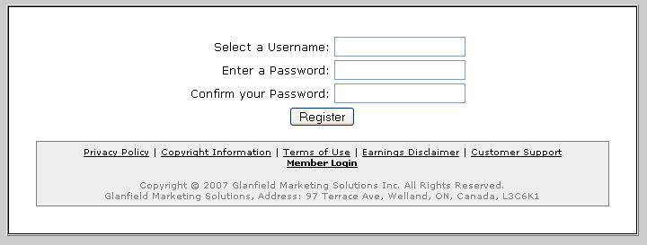

4. Payment Processor

The next step would be to send them to the payment processor to start their subscription.

Luckily the same payment processors that I recommend for selling your info-product can be used for recurring payments as well.
5. Members’ Area

The members’ area is where all the fun happens, as it is where all your paid customers are!

This is simply where you post all the new content and stay in communication with your members.

Here are a few tips to make your members’ area even better:

- Keep it simple. Don’t clutter it with too many categories as that can get confusing for your customers.
- Have a community. You can do this through a simple forum where members can communicate with each other.
- Have a “Latest Additions” section on the home page. This will allow returning members to quickly find new information.
- Update the members’ area regularly with new content to keep things “fresh” and exciting for your members.

As for the design of the look and feel of the members’ area, that really is up to you. The only stipulation is that it should be simple and easy to use.

Here is a screenshot of my members’ area for www.bbotrafficclub.com:

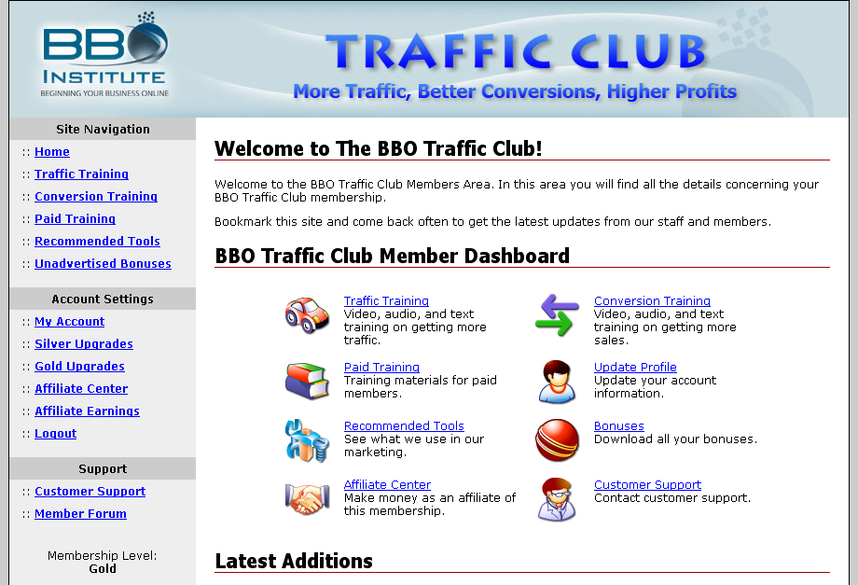

Simple, clean, and hopefully professional looking!
How much content should you have before you launch?

This is a question that I would often get when teaching how to make membership sites.

The truth is you don’t need much, especially if you are offering the core training like I have suggested.

Here is a guideline for a minimum amount of material to include in your membership site before you launch:

- Core training products
- Recommended resources
- Forum
- 3-5 articles
- 3-5 videos

That’s it! This is just a guideline, so if you want to have 5 videos and nothing else, go for it! Just make sure there is enough in there that when people first sign in it doesn’t look like a ghost town.

The forum will be one of the hardest parts to get going as it takes a lot of participation to make them work, but you can overcome this by constantly being active on the forum and by sending out emails to your members with the latest posts and news on the forum.
Once you have your membership site created you will be ready for the next stage – getting members!

This is an exciting point as it is what can finally start building up the residual, steady profits that you have been trying to make all this time.

Chapter 4 – Linking the Front-End to the Back-End

At this point you are going to want to start getting more signups for your membership site. This is the crucial part to ensuring success and stability in your business.

The first thing you need to do is to have a goal in mind of what you want to achieve. How many monthly subscribers would you like to have?

For example, if you have a website that charges $19.95 per month and you want to make $10,000 in revenue per month, then you need roughly 500 paying subscribers.

That means if you work hard and get 100 subscribers per month, within 5 months you will be making $10,000 per month!

However, there is also attrition (i.e. customers cancelling their subscriptions), so it will most likely take a little longer, depending on how good you are at keeping members happy.

Remember, the two things that you need to manage with a membership site are:

- Customer Acquisition.
- Customer Retention.

By keeping acquisition high and retention low you should always see an increase in your month to month revenues.

In this chapter we will focus on how to acquire customers into your membership site so that you can build that all-important residual income that we have been talking about.

There are a few ways we are going to do this:

- Linking the front-end to the back-end.
- Free offers (e.g. free CDs).
- Straight selling of your membership site.

The first is linking your front-end product to your back-end.

Let’s quickly review what those two things are:

Front-end Product – your first product that you already made
Back-end Product – your membership (or software) site that charges a monthly fee

The idea now is to use the front-end product to get more signups for your back-end product.

This is probably one of the easiest ways to acquire new customers, simply because of the method that you are going to use.

Here is what you will be doing – you will offer a free month (or two) as a bonus for purchasing your front-end product.

The number of months that you give for free depends on the price of the front-end product and the cost of the membership site.

For example, if you sell an e-book for $47 and you have a membership site that costs $29.95, you could offer as a bonus two free months, which makes the bonus actually worth more than the e-book!

This adds a tremendous amount of value to the sale of your front-end product, AND creates a new customer for your membership site.

Here is the important part – in order to get their free month(s) the customer needs to give their credit card information to start their membership. That way once their free months expire they will be automatically billed for each month afterwards, or whatever terms they agree to.

Sure, it will be a couple of months before you start getting residual revenue, but once it starts, it will build tremendously well and will stabilize your income. Besides, one or two months really isn’t that long, and should be stabilized by the fact that you are selling your front-end product to generate revenue.
Now, here is the catch – not everybody will take their free bonus month(s), meaning that you will not get as many customers as you potentially could get.

That is why you must advertise the bonus to paid customers. It is not enough to mention that they will get it and wait for them to email you asking how they can redeem their free months. You must make it prominent so that it is one of the first things that they do.

Here are a few ways of how you can make sure you get the maximum number of customers claiming their free month(s):

Make it the first thing they see in the download area

Don’t be shy. Tell them that before they download the e-book or watch a video that they should claim their free month(s) of your membership site.

For example, you could put a box like this at the top of your download area:

WAIT! Before you do anything else…
Make sure you claim your two free bonus months (worth $50!) of our weight loss membership site by clicking on this link:
Click here to get your two free bonus months now…

By making it prominent you will get more people to sign up right away. Remember, the best time to get somebody to take action is when they have already taken action, so the download area is your best bet.

Advertise the free month(s) in your auto-responder follow-up

Another area where you can get your customers to take their free month(s) is in the auto-responder follow-up series that goes out to customers.

In other words, when somebody purchases your front-end product you have them register their name and email address before they can download it. This allows you to set up a sequence of emails that will only go out to paying customers.

You should mention the free bonus month(s) in the first few emails you send out, starting with the first one.

Here is an example email that could be sent out as the first in the auto-responder sequence:

Hey Matthew,

Thank you for your purchase of my e-book Weight Loss for Dummies! I know that you will be very happy with your purchase.

You can download the e-book here:

http://www.example.com/download.html

Also, because you purchased this e-book you get a bonus free month of my membership site Weight Loss For All, valued at $29.95.

You can get your free month by clicking here:

http://www.example.com/freemonth.html

Enjoy!

Jack Humber
Fitness Trainer Extraordinaire

You should also mention it in a few follow-up messages in the P.S., such as the following:

P.S. Did you get your free month of my Weight Loss For All membership site yet? If not, make sure you click here to get started now:

http://www.example.com/freemonth.html

Once you get started you will be able to connect with other people trying to lose weight just like you, and also access some exclusive videos and training that only members can get.

And finally, make sure you send out an email dedicated solely to telling your customers to claim their free month(s). Here is another sample email to show you what I mean:

Hey Matthew,

Just a quick question - did you get your free month of the Weight Loss For All yet?

If not, you can get it here:

>>> http://www.example.com/freemonth.html

Remember, in the Weight Loss For All membership site you get access to exclusive training on how to lose even more weight quicker, so make sure you sign up now!

>>> http://www.example.com/freemonth.html

Jack Humber
Fitness Trainer Extraordinaire

Now, you might be wondering why we need to push so hard to get customers to claim something that is a bonus. However, you will be surprised to see how many people make a purchase and then never even download the product, never mind claiming one of the bonuses.

You will probably not get all of your customers to claim their free month(s), but by implementing the above emails and the addition of an advertisement in your download area, you will maximize how many decide to cross-over.

Why not just have a forced-continuity program?

A forced-continuity program is where the customer automatically gets enrolled in the membership site when they buy your front-end product. This can work well, but will most likely lower the sales that you will get of your main product.

I have found that it isn’t worth it, but I know other marketers who have found otherwise. What that means is you need to test to see which works best for you.

I recommend starting just the way that I have described above, and then trying out different things to see if you can increase your numbers.

However, where a forced-continuity program is more applicable is in the next section we will talk about:

Free CDs (and other free offers)

Here is a system that works incredibly well mainly because it offers something of high perceived value.

Basically all you do is offer a free CD with some useful information on it. The customer only needs to pay for shipping and handling, which actually covers the cost of the creation and shipping of the CD, so you lose no money.

However, with the offer you also give them 30 days free to your membership site, and then start to bill them automatically afterwards.

This should, of course, be made very clear at the time that the customer enters their credit card information. I have seen free CD offers where it is not very obvious that the customer was going to be charged automatically afterwards, which I believe to be unethical, as well as the source for future problems that you have to deal with in customer support.

The great thing is you probably already have all you need to create the free CD offer. All you need is 30-60 minutes of audio from something that is of value to your customers.

For example, if you sold an e-book as your first product, why not create an audio version by recording yourself reading it and then put that on a CD?

Or, you can host a teleseminar and have it recorded, and offer that on the free CD.

It shouldn’t be hard to create a 30-60 minute audio that you could then use in your offer for your free CD.
To find vendors who can create your CDs for very low prices check out the resource page at www.bboinfiniteprofits.com/resources.php.

Finally, you can simply sell your membership site

Not everybody that is on your list is a customer. In fact, you probably have far more prospects than you do customers.

So why only allow your paid customers the opportunity to sign up for your membership site? If that was the only way for people to get in, then we wouldn’t have gone through all the fuss of creating a sales page, benefits page, and the demo video for your membership site.

In other words, sell the membership to your prospects as well! What I like to do is insert a few auto-responder messages advertising the membership site and the $1 trial offer in my various prospect auto-responders.

This has lead to many sales. However, there is something else that I have done as well that leads to even more sales:

An Affiliate Program!

You should always have a built-in affiliate program for your membership site, and you should always provide as much incentive as you can to get your affiliates to promote.
If you used one of the payment processors that I recommend on the resources page you will already have an affiliate program in place, so there is no extra programming needed to get this working.

So how do you get affiliates to promote? I like to look at this in three ways:

- Monetary incentive (i.e. good commission structure)
- Pre-made affiliate tools (i.e. the work is done for them)
- Affiliate training (i.e. teaching them to sell for you)

First off, there needs to be a good monetary incentive. If you only offer 20% commission levels (don’t laugh, I have actually seen software sites that offer 10-20% commissions), then you will find it hard to have people really advertise for you.

I like to offer 40-60% commission levels, depending on my month to month costs. If there are no real monthly costs for me, then I offer 50-60%. If there are monthly costs (e.g. software maintenance, extra customer support), then I usually offer 40-50% commissions.

Basically I offer as high a commission rate as I can afford. That motivates affiliates to promote for you.

Second, you need to create all the tools for your affiliates. They shouldn’t have to do all the work to promote your program.
Here are just a few of the tools I like to provide my affiliates (in order of importance):

- Pre-written emails (2-5)
- Pre-written blog reviews (2-5)
- Pre-written Google Adwords ads, along with keywords
- Rebrandable PDFs (see resource page to learn how to do this)
- Banner ads (all standard sizes)
- Private label articles (i.e. they can change them however they like)

Of course if there are more tools you can provide, provide them! The easier you make it for your affiliates, the more you will find that they will promote your product.

Time for more products…

The next method for getting more members into your membership site is to create more front-end products.

We will discuss this in the next chapter.

Chapter 5 – Beefing Up Your Front-End

By this point you should have a front-end product created as well as your back-end continuity product (i.e. your membership or software site).

The question that comes next is this:

How do you take this to the NEXT level?

The next level is where you are making $10,000 per month from your membership site, and all you really have to do is update the content once or twice a week (or do it in advance and go on vacation!).

There is only one problem with this – you will continually need to get new customers in order for you to continue making money. Now, this is not as big a problem as with front-end products as most customers will continue to pay month to month, but there will be a certain amount of attrition on a monthly basis.

Here is the other problem – as soon as your site is more than one month old most people will not think it is a big deal (with a few exceptions). I have found that most products that do well at first suck later on because everybody is tired of hearing about it!

So how do you overcome these two problems? Simple – build more front-end products!

Front-end products are exciting. They are usually somewhat unique. They are fresh. They are new. This is what keeps your customers interested in you. Ironically it is also the least profitable as a lot of work is put into each front-end product.

That is why you want to continue making front-end products with the purpose of getting more members into your membership site. That makes front-end products MUCH more profitable, and it allows you to do fun stuff, like:

- Offer 110% commission to affiliates (you’ll get it back in the back-end)
- Offer crazy bonuses to your customers
- Host your own huge product launches
- Keep affiliates interested in your business
- And more…

On average you should probably crank out three or four new front-end products per year, or even more if you are really ambitious.

The difficulty is figuring out how you are going to find time to make these products WHILE creating content for your membership site WHILE dealing with JV partners and other traffic methods WHILE trying to actually relax and take advantage of all the extra money you are making.
That is why I came up with my…

SUPER-LAZY PRODUCT CREATION SYSTEM

It is super-lazy, but it is still super-valuable to your customers.

Here is how it works: You need to keep making new content for your membership site, right? And you need to keep making new front-end products, right?

Well, why not fuse the two together and do both at the same time?!?

In other words, use the content you create for your membership site for your front-end products!

For example, let’s say you run a dog training membership site. You try to make two videos per week on various aspects of dog training.

Well, next month why not focus on making videos about basic dog training (i.e. sit, stay, fetch, etc.)? Once you are done 8-10 videos you can then package them together and sell them on their own as a basic dog training course!

The basic dog training video course becomes a front-end product. All you have to do is create a sales letter and download area, list it on ClickBank (or whatever you use to process payments), and tell all your JV partners about it and get them to promote it!

Of course, you will offer a month or two to your membership site as a bonus to buying this new video course.

This accomplishes three main things:

- It creates new content for your membership site, keeping your members happy.
- It acquires new members for your membership site.
- It makes your members happy as they see they are getting content that is obviously valuable (it’s being sold, isn’t it?) included in their membership.

It’s a win-win-win situation for everybody.

How to Make Your Front-End Customers LOVE You Even More

Want to know a secret that will gain you even more sales, more members to your membership site, less refunds, and happier customers?

Then consider the following:

You spend a month creating content for your membership site, and then package it together as a front-end product and sell it to get more paying customers.
You then continue to make more content for your membership site because you need to in order to keep them happy.

However, you don’t plan on making another product for a couple more months, so you have all of this extra content that only your members are seeing.

Well, why not give at least some of that content to your paying customers as an unadvertised bonus for purchasing the course that you sold them? They’ll love you for it!

Let’s go back to the dog training example to clarify what I mean.

Here is your content creation schedule:

January:
-create 8 videos about basic dog training for the membership site
-package those and sell them separate as a Basic Dog Training Video Course

February:
-create 8 more videos about basic dog training for the membership site
-give 4 of them as bonuses to customers of the Basic Dog Training Video Course
-use each video as an opportunity to remind customers that they get a free month at your membership site, and that there are even more videos there

March:
-create 8 videos about advanced dog training for the membership site
-package those and sell them separately as an Advanced Dog Training Video Course

April:
-create 8 more videos about advanced dog training for the membership site
-give 4 of them as bonuses to customers of the Advanced Dog Training Video Course
-use each video as an opportunity to remind customers that they get a free month at your membership site, and that there are even more videos there

Are you starting to see the potential here?

You will be known as the great over-deliverer in your niche market, making your JV partners and your customers very happy, which leads to less refunds and cancellations AND more signups at your membership site.

You don’t have to do that much content creation…

You might be looking at all the content creation I was talking about and thinking that it is a lot. I admit that two videos a week would be a lot to sustain over the long term.

Just remember that there are other ways to create content, including having guest speakers and contributors (about half of my content in my membership site is created by other people, and it is still great!).

Don’t forget as well that when you are in a content creation mood you can always crank out more content than normal and then save it for when you don’t feel like working (did anybody say vacation?).

Here are some ideas to finish things off…

We are nearing the end of this e-book and training, so I wanted to leave you with a list of ideas for front-end products that you could use to build even more content for your membership site and make even more valuable products.

This list is not exhaustive, so feel free to use your creativity and imagination to get more ideas.

- Host a teleseminar series with several guest speakers centered on a themed topic.
- Create a video series on a specific topic.
- Write an e-book and post it chapter by chapter to your members.
- Have a series of “member tips” where members create content (video, audio, articles, etc.) on a themed topic.
- Host a contest for the best tips with your members.
- Start a JV relationship where somebody else creates content on a regular basis in return for something of value to them (e.g. promotions to your email list, consultations).
- Hire somebody to make content on a regular basis.
- Purchase PLR or Resale Right products and give them to your members.
- Have an “Ask the Expert” section where you post answers to common questions from your members.

As you create more and more front-end products you will find that your success will increase substantially, not because you are selling more products, but because you are constantly getting more people into your membership site, increasing your residual profits.

To your success!

Matthew Glanfield

P.S. Don’t forget to check out our resources page at www.bboinfiniteprofits.com/resources.php.

